**Twitter Sentiment analysis**

Tweepy library is used to extract the tweets based on the given query. The tweets are extracted based on the location, search term(query), language and the date.

Vader sentiment analysis is performed on the extracted tweets to categorize the tweets as positive, negative and neutral.

The hyperlinks, emojis etc are removed and only the final text is used to perform the sentiment analysis.

We experimented on textlblob for sentiment analysis and observed that Vader sentiment analysis is more reliable.

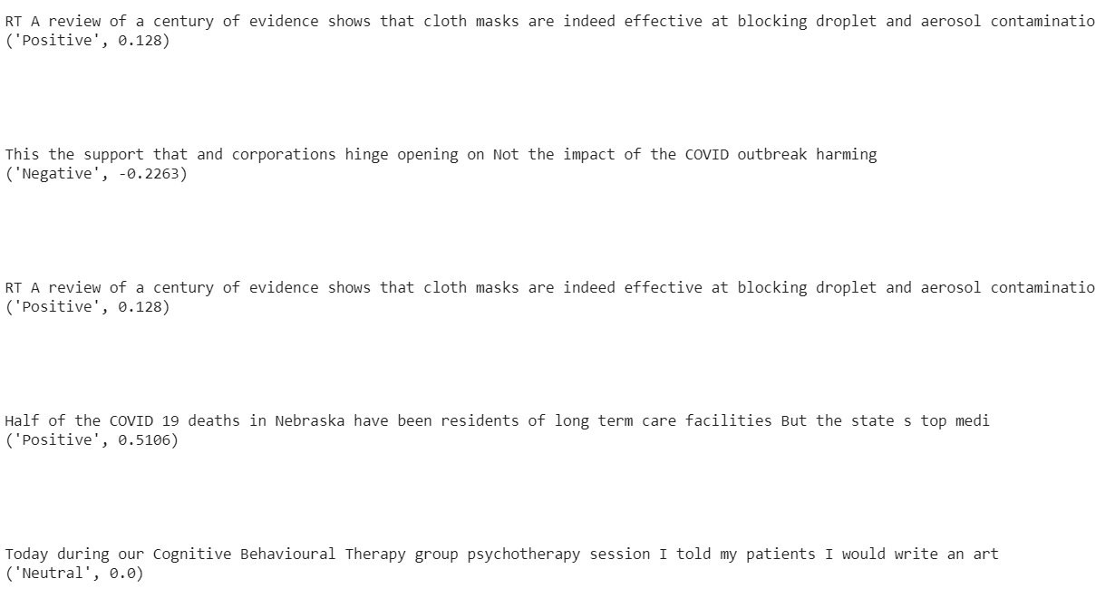

**Output of twitter API:**

The user gives the input in the format as a json, with the attribute location and also the number of tweets that he/she wanted to extract.

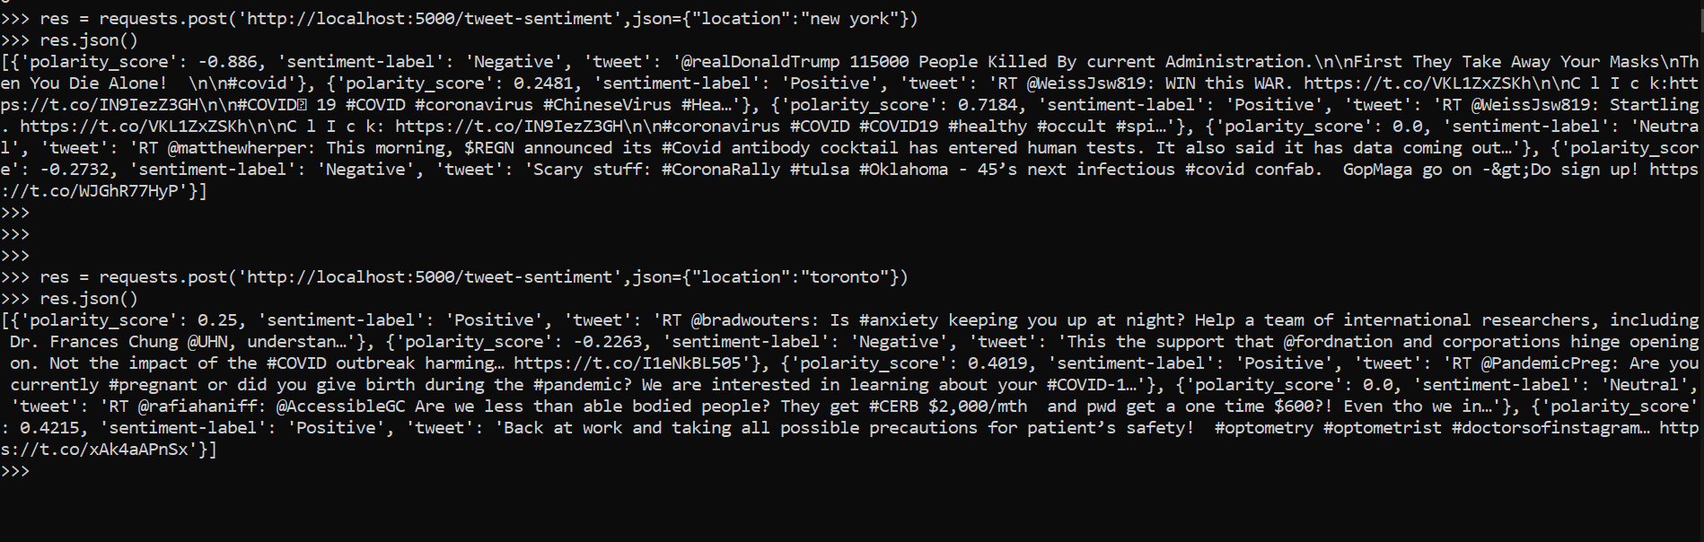

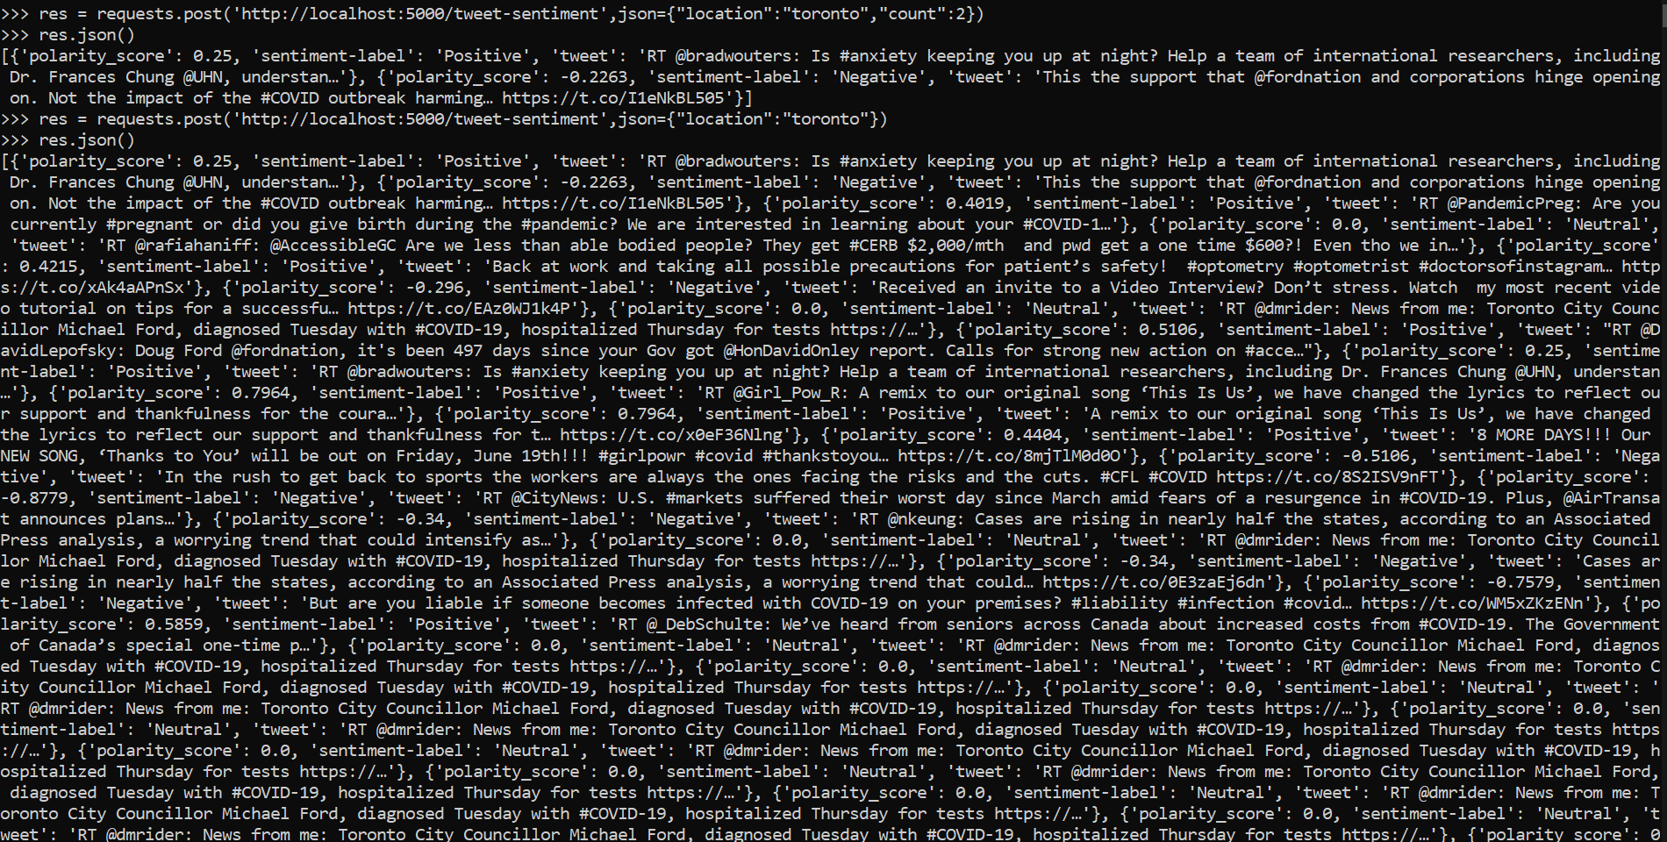

The latitudes and longitudes of a city are obtained by using geopy API. Other API’s like geocoding API, openweather API, Opencage Geocoding API are experimeted. However the acuuracy of latitudes andd longitudes, number of requests are better for geopy API. 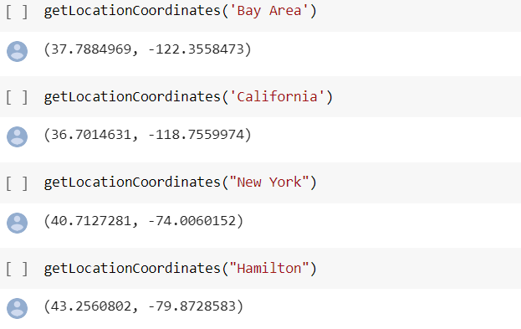

**Input Response:**

The API requires the input in the form of a JSON object with the parameters,

* + location
  + count (optional)

The location parameter is used to fetch the tweets that are posted from that location.

The count parameter is optional., It is used to retrieve a specified number of tweets. When the parameter is used ., By default it fetches 100 tweets.

**Output Response:**

The API outputs a array of JSON object, with each JSON object containing the parameters,

* + polarity_score
  + sentiment-label
  + tweet

The polarity_score parameter contains overall polarity of the tweet

The sentiment-label parameter specifies, the sentiment of the tweet.

The tweet parameter contains the exact tweet for which the sentiment analysis was performed.

Tweepy documentation: <http://docs.tweepy.org/en/v3.5.0/>

Geopy API: <https://geopy.readthedocs.io/en/stable/>

Geocoding API: <https://developers.google.com/maps/documentation/geocoding/start>

Openweather API: <https://pypi.org/project/openweather/>